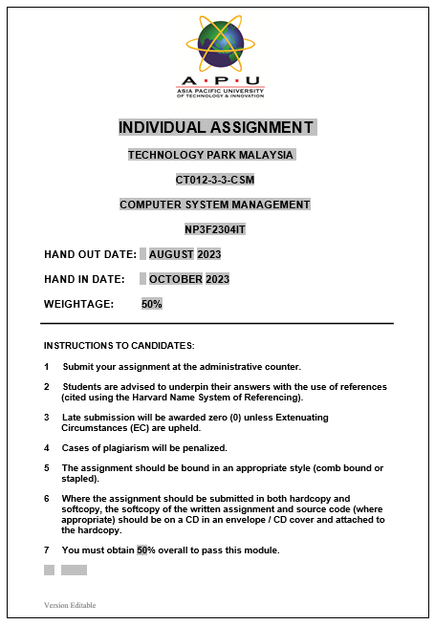

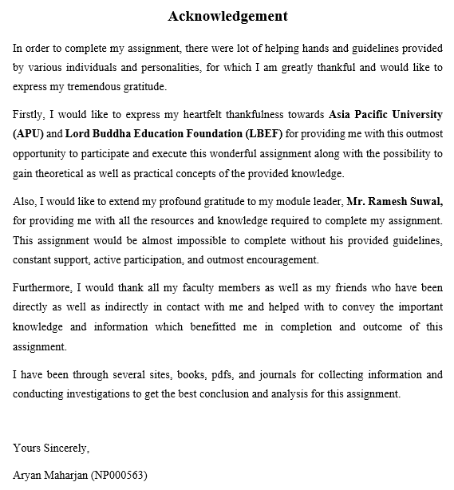

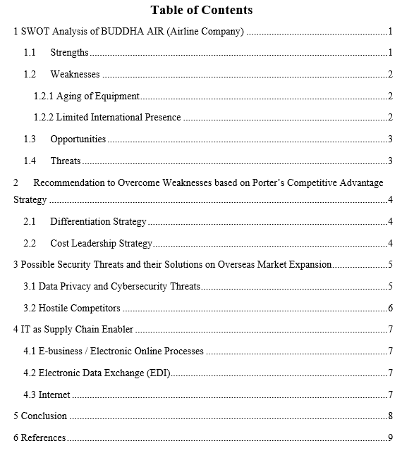

# 1 SWOT Analysis of BUDDHA AIR (Airline Company)

SWOT Analysis is a strategic use of plans and technique for strategic management as a tool which helps to determine the overall evaluation of both internal and external findings, which includes strength and weakness as internal, and opportunity and threats as external information. This analysis helps to gather a comprehensive summary of the state where the company is situated in the market as well as help to come up with a strong strategic plans and decisions (Greene, 2021)

|  |  |
| --- | --- |
| **STRENGTHS** | **WEAKNESSES** |
| * Reputed brand known for quality services in Nepal. * Safety Record * Modern infrastructure and technology * Broad range of Services | * Limited International Presence * Competition * Aging of Equipment |
| **OPPORTUNITIES** | **THREATS** |
| * International Expansion * Use of Modern Equipment * Tourism Growth | * Natural Disasters * Price Competition * Increased Fuel Price * Emerging Technologies |

## Strengths

Every company have their own strength which are internal traits which help the company to achieve advantages against their competitors. Buddha also has their strengths recognized and used it to build their competition in the market and prosper in the business. One of the strongest strengths for Buddha Air is their brand reputation for best civil aviation service available in the market. The company focuses on upgrading their infrastructures and investing in Research & Development which provides them with advantages that keeps them few steps ahead from their competitors. Along with that, the company focuses on regular maintenance and supervision of the equipment and resources which has led to have a huge number of successful flights throughout the country. The company has huge advantage over the services provided to the customers with a very healthy feedbacks (Elwalda & Mousa, 2021).

## Weaknesses

For a company, weaknesses refer to the internal traits which hampers the company’s growth and negatively affect the company’s presence in the competitive market. Based on the SWOT analysis performed, the following are the two weaknesses which has been identified: Aging Infrastructure and Limited International Presence. The following are the weaknesses and their respectively summary.

### 1.2.1 Aging of Equipment

Buddha is a leading airline company but has some weakness as well, one of them is their deteriorating condition of the equipment with time. All the equipment has their safety evaluation done for the use in the service by the company which helps to prevent the use of faulty resources. The use of old aircraft by the company can be one of the major weaknesses in the company as these aircrafts seems to be less efficient, risky and reduce the customer satisfaction. The aging of equipment is natural which when failed to recognize could lead to severe outcomes which can negatively impact the company’s reputation or lead to the downfall of the company. The major assets of the airline are its aircrafts which run old with time. These aircrafts have less efficiency in terms of fuel consumption along with increased cost for its maintenance and servicing. (Wals, 2023).

### 1.2.2 Limited International Presence

Another major weakness for the company is its limited international presence. Since, the airline company is registered to provide the services within the country with a single international service limited to only India, this is one of the weaknesses for the company. This weakness leads to failure of the company to international market and have their absence from the international market revenue. With the absence of international flight services, the customers tend to get used to the competitors of the company and lose their loyal customers. Limiting the company’s services to the domestic market prevents the companies outgrow and lose their opportunities with foreign partnerships and alliances. This tends to affect the growth of the company negatively. (Goodwill, 2020).

## Opportunities

In SWOT analysis, opportunities are the external factors which helps the company achieve their competitive goals and achievements. Based on needs on people, Buddha Air has opportunity to expand their connectivity by providing international airline services to more interested people. There is great opportunity for the company to focus on increasing the number of tourists in the country by using the country’s great natural resources and its beauty. With the increase in both the international and domestic tourists, they tend to use the services of the company which tends to benefit the company positively. Along with that, the company can focus on improving their aircraft and its collection with up-to-date ones which tends to improve the energy consumption, customer satisfaction as well as security benefit for the customers. Hence, the company has a lot of opportunities for attracting the customers by providing best customer experience during the service period (Lenon, 2021).

## Threats

For a company, threats refer to external factors which can directly hamper the outcome and cause huge challenges. Threats are negative circumstances which needs to be researched beforehand as they can hugely affect the goals and objectives of the company. One of the major threats of the company is the natural disasters like earthquake, hurricane or storms, or flood which can affect or ground the services provided by the company. Another threat that exists for the company is price competition which arises when the existing competitors reduce the cost for the services creating a diversion to the current customer base. Along with that, the price of fuel which is used for the aircraft plays a huge role on the company’s overall profit and revenue generation. Therefore, the increase in the price of aircraft’s fuel has a heavy impact on the company as it tends to increase prices for the services as well which could tend to repel the customers. Lastly, the inability to adopt to current trends such as engaging in latest technology can backlash the company’s performance as the new technology can provide more efficient services (Wales, 2019).

# Recommendation to Overcome Weaknesses based on Porter’s Competitive Advantage Strategy

Porter’s Competitive Advantage Strategy is a set of distinct research and methods that are explained with a solo goal of gaining advantage over the competitors of the company based on three different approaches. The following are the two recommendations on Buddha Air company to overcome the possible drawbacks based on this advantage strategy:

## Differentiation Strategy

Based on Porter’s Competitive Advantage Strategy, the company can overcome the weakness by implementing one of the strategies called differentiation strategy. According to this strategy, the company is required to stand out in the market and gain a huge outthrust from the competitors. Buddha Air can work on investing some funds on their research and development team which will focus on bringing out more reliable services and needs based on the customers such as cheaper fare rates, exciting offers, comfortable seats, satisfying user experiences, and more reliable services which will help the company grow along with a strong customer base. This strategy will allow the company to bring out distinct features which are not easily replicable by the competitors and allow the company to stand out in the market. To make this strategy more effective, the company needs a strong and active research and development team along with constant feedback collection from the users or customers and have a strong background check for the market (Grins, 2020).

## Cost Leadership Strategy

Based on Porter’s Competitive Advantage Strategy, the company can overcome the weakness by implementing another strategy called cost leadership strategy. This strategy helps to gain overall advantage and benefits of the company by handling internal operations and other operations as well. The company can implement this strategy by working on research and auditing tasks which will help to bring out reports of internal tasks and reduce the optimum price wherever possible to reduce the cost. This strategy can be effective by implementing various tasks in the company such as investing in the modern technology which will help reduce the cost along with resources consumption. It can also be implemented by reducing the price in contracts with possible suppliers and making the supply chain as narrow as possible to reduce operation cost and be able to provide compromising services which are efficient and can stand out in a very low price than any other competitors (Daniel, 2020).

# 3 Possible Security Threats and their Solutions on Overseas Market Expansion

Expanding the company’s business to a new level such as oversea has both positive and negative effects on the company. With this expansion, the company faces several security threats which needs to be handled with respective overcoming solutions to keep the company standing and avoid losses. The following are some of the possible security threats which may arise along with their corresponding solutions:

## 3.1 Data Privacy and Cybersecurity Threats

**Threat:**

Data privacy is a huge concern in all the countries along with that it might be even more concerning in certain countries. The company might face several cybersecurity threats and data privacy threats due to cyber-attacks if they don’t have strong and reliable security measures implemented in their system. Along with that, the rules might hamper the security based on the country’s existing cybersecurity laws. The company might have to face legal charges and spend unnecessarily on penalties and lawsuits if the company doesn’t abide by the oversea country’s law. The database and other resources need to have a portable connectivity for functioning which can be hacked and breached which can lead to data breaches which when falls on wrong hands can ruin the company’s reputation and overall establishment (Vandoru, 2021).

**Solution:**

To overcome the above threat, the company needs to conduct proper research on the requirement of the security policies and law that are existing in the targeted country and implement the respective policies to comply with it. The company needs to invest in strong security measures such as encryption, firewall protection, intrusion detection system along with antivirus and alert systems. The database needs to have strong access and authorization to maintain the data securely. Along with this, the company needs to train their staffs regularly to improve their skills and maintain proper security in the company and avoid possible human errors (Goyal, 2020).

## 3.2 Hostile Competitors

**Threat:**

When a company enters a new country, they are exposed to a new set of competitors which have their own new strategies. One of the threats is price war which refers to the competition among the competitors by cutting down the price for the service to make them more attractive to the customers even to the point which might lead to loss. The company might also face charges based on the existing laws such as intellectual property threat which can occur if similar company with existing design, and services are already available. Some of the competitors can use unfair market practises such as circulating false news which can cause the customers to be diverted from the services and choose alternatives. The competitors of the overseas can have their strategies which can be very aggressive on the company such as stealing the customers, ruin the company’s brand image and make their own stand out and use sales tactics which are favourable to them but make the environment unfavourable for the company (Choiriah & Sudibyo, 2020).

**Solution:**

To overcome these threats, the company needs to plan and conduct proper research of the environment along with the market and all of the competitors which are present in that overseas country. The country needs to protects the intellectual rights by obtaining all the necessary copyrights, patents, and trademarks. Focusing on maintaining the original brand quality can help the company protect its customer base and stop them from unethical competitors’ marketing. Along with that, the company needs to invest in pricing strategy to stay strong and stand out against wars on competitors price wars (Vlados, 2019).

# 4 IT as Supply Chain Enabler

The use of Information Technology to enable the supply chain can be one of a strong strategy for Buddha Air, an airline company while trying to expand the business. The company will have a remarkable change in terms of supply chain’s efficiency along with transparency with the implementation of Information Technology. The following are the detailed critical examination of how IT can be helpful when used as a supply chain enabler:

## 4.1 E-business / Electronic Online Processes

The use of IT in Supply chain will allow the company to have real-time insights of the supply chain enabling supply chain visibility. With the available insights, the company can track the movement of the resources efficiently and handle any errors or problems on hand making the company’s business process efficient and fault-less. This allows the company to keep track of all the equipment, along with how the different aircrafts are functioning and their locations. Hence, the use of IT as a supply chain enabler helps to generate a better fault tolerance and forecast the problems effectively (Gupta & Kumar, 2020).

## 4.2 Electronic Data Exchange (EDI)

Electronic Data Exchange is an IT tool which helps in the supply chain by enabling the smooth flow of data among the company’s associations. It allows exchanging the documents such as invoices, shipment billing, and purchase orders which are crucial from business point-of-view in their own standard form between two computers. With this technology, the company can exchange data among their suppliers and other supply chain bodies in a quick and secured manner. This helps to reduce human errors, maximize the efficiency of the processes and reduce the manual requirement of data input (Tanwar, 2021).

## 4.3 Internet

The internet helps to connect the company with all the bodies involved in the supply chain and exchange the necessary information and data effortlessly at ease. Along with that, the use of IT allows the collaboration among the concerned people with the help of portal such as cloud-based servers which directly impacts on the company’s business processes. With the help of internet, the company can efficiently plan the future demands and manage the inventory easily. Along with that, the internet acts as a platform to connect the company with their customer base. This eliminates the traditional face-to-face market and unlocks the new right-to-your-door-step delivery from the click of the mouse or swipe on the screen of the customer (Kutsuri & Langley, 2021).

# 5 Conclusion

To sum up, an extensive plan is needed to succeed in a new market. A complete plan consists of anticipating possible security risks, utilizing information technology for supply chain optimization, and discovering and reducing internal vulnerabilities through Porter's techniques. By using these strategies, businesses are able to both manage the difficulties associated with growth and take new possibilities in the global marketplace. In addition to reducing risks, this comprehensive approach promotes flexibility and effectiveness in an industry that is always changing. In the end, companies using these tactics are more likely to see long-term growth and accomplishment in international markets.

# 6 References

Choiriah, S., & Sudibyo, Y. A. (2020). Competitive Advantage on Success of Management. *Journal of Economics and Finance*.

Daniel, P. (2020). Cost Leadership Strategy: Porter's Strategy. *International Union of Business Journal*.

Elwalda, A., & Mousa, M. (2021). SWOT analysis applications: An integrative literature review. *Journal of Global Business Insights*.

Goodwill, T. (2020). SWOT Analysis in terms of Global Expansion. *Journal of Business Insights* .

Goyal, A. (2020). A Critical Analysis of Porter’s 5 Forces Model of Competitive Advantage. *SSRN*.

Greene, F. J. (2021). SWOT Analysis: It's Time for a Product Recall. *SWOT Overview*.

Grins, S. (2020). Porter's Advantage Strategy. *Business Insight Journal* .

Gupta, H., & Kumar, S. (2020). Enablers to supply chain performance on the basis of digitization technologies. *Emerald Insights and Journal of Business*.

Kutsuri, G., & Langley, D. (2021). Impact of digitalization on improvement of economy, IT and Internet of business. *Journal of Industrial Information Integration*.

Lenon, J. (2021). Insights of the SWOT Analysis: Features Unleases. *Journal of the Science Behind Business*.

Tanwar, S. (2021). Electronic Data Exchange in Business. *Journal of Information Security and Applications*.

Vandoru, R. (2021). Security Threats and Its Solution. *Cybersecurity and Data Protection Article*.

Vlados, C. (2019). Porter’s Approaches and the Competitiveness Web. *Approach of the Strategy based Journal Times*.

Wales, R. (2019). Threats and Opportunies in Business. *Journal of the Business Times*.

Wals, A. (2023). A SWOT analysis: Implications for educational practice and research. *Innovations in Education and Teaching International*.